

PUPIL ATTENDANCE policy

The Policy was formally adopted by the Governing Board on: | Date: 25th September 2025
Date for review:- | September 2026

The name and contact details of the Senior Attendance Specialists are -

James Shane (Deputy Head)
james.shane@css-essex.co.uk
Tel: 07483 059920

Kristina Jackson (Attendance Officer)
Kristina.jackson@css-essex.co.uk
Tel:07872107972

Michelle Steadman (Head of Service)
michelle.steadman@css-essex.co.uk
Tel: 07301018134

The name and contact details of the service staff member pupils and parents should contact about attendance on a day-to-day basis and if you have concerns this can be passed on to the relevant person.

Wickford | Sharon Harvey (Admin)  Kristina Jackson (Attendance) | 01268 552482  07872107972
Primary | Sharon Harvey (Admin)  Kristina Jackson (Attendance) | 01268 552482  07872107972
Fairview | Kristina Jackson (Attendance) | 01268 542367  07872107972
Medical Education Team South (METS) | Katie Price (Admin) | 07872 107943
Medical Education Team West (METW) | Katie Price (Admin) | 07872 107943

The name of our linked Governor with responsibility for monitoring attendance is:

Ruth Wootton

Children’s Support Service (CSS)

Pupil Attendance Policy

At CSS our key values are: Respect - Resilience - Aspiration
Underpinned by:
Compassion and Kindness
We are friendly, polite, generous and considerate. We try to help our young people and be there for them when they need us.
Hope
We find and build on young people's strengths and interests, and support them to be happy, confident and lead fulfilling lives.
Connection and Belonging
Positive relationships underpin all of our policies, practices, routines and interventions.

Introduction and Background

CSS recognises that positive behaviour and good attendance are essential in order for pupils to get the most of their school experience, including their attainment, wellbeing and wider life chances.

This policy is written in accordance with the Department for Education’s guidance on school attendance and its framework for how schools can support an improvement in school attendance. The guidance states: ‘Central to raising standards in education and ensuring all pupils can fulfil their potential is an assumption so widely understood that it is insufficiently stated – pupils need to attend school regularly to benefit from their education. Missing out on lessons leaves children vulnerable to falling behind. Children with poor attendance tend to achieve less in both primary and secondary school.’
This policy sets out expectations for attendance. In doing this, we aim to:
• ensure that every student succeeds whilst at CSS
• ensure that every student has access to the widest possible range of opportunities when they leave CSS
• and promote students’ welfare and safeguarding

To achieve those goals, at CSS, we believe it is essential that students are not absent from school.

Our aim is to foster a sense of responsibility, a joy of learning and to create a community where learning is recognised as important and crucial to securing well-being and increased life chances. Attendance is a safeguarding issue - the health, safety and wellbeing of students is the trust’s key priority.
CSS staff work closely with link agencies to ensure maximum attendance and therefore achievement for all students. Staff work with parents/carers to achieve good attendance and involve the Local Authority in the best interests of the child.
Students who attend regularly will succeed and secure economic wellbeing in the future. They will enjoy making a positive contribution.

The Department for Education (DfE) has produced statutory guidance for maintained schools, academies, independent schools, and local authorities. It is called “Working together to improve school attendance” and it includes a National Framework in relation to absence and the use of legal sanctions. Our Service Attendance Policy reflects the requirements and principles of that guidance.

It has been developed in consultation with the management committee, teachers, local Headteacher Associations, the Local Authority and parents and carers. It seeks to ensure that all parties involved in the practicalities of school attendance are aware and informed of attendance matters in school and to outline the school’s commitment to attendance matters. It details the responsibilities of individuals and groups involved and the procedures in place to promote and monitor pupil attendance.

Promoting Regular Attendance
At CSS, we believe in developing excellent patterns of attendance and set high expectations for the attendance and punctuality for all our pupils from the outset. It is a central part of our school’s vision, values, ethos and day to day life. We recognise the strong connections between attendance, attainment, safeguarding and wellbeing.

The name and contact details of the Senior Attendance Specialist (the senior leaders responsible for the strategic approach to attendance in our school) are:

James Shane (Deputy Head)
james.shane@css-essex.co.uk
Tel: 07483 059920

Kristina Jackson (Attendance Officer)
Kristina.jackson@css-essex.co.uk
Tel:07872107972

Michelle Steadman (Head of Service)
michelle.steadman@css-essex.co.uk
Tel: 07301018134
Helping to create a pattern of regular attendance is the responsibility of parents, pupils and all members of school staff.

To help us all to focus on this, we will:

Submit a daily attendance return to the Department for Education, in line with the legal expectations placed on all schools;
Give parents/carers details about attendance during the initial induction;
Build strong relationships and work jointly with families;
Promote the benefits of high attendance;
Accurately complete admission and, with the exception of schools where all pupils are boarders, attendance registers and have effective day to day processes in place to follow-up absence as required by law;
Celebrate excellent attendance by displaying and reporting individual and class achievements;
Reward good or improving attendance;
Report to parents/carers regularly on their child’s attendance and the impact on their progress;
Contact parents/carers should their child’s attendance fall below the service’s target for attendance.

Understanding Types of Absence
When a student is absent from school, the law categorises that as either ‘authorised’ or ‘unauthorised’. The law states that it is for the academy to determine into which category any absence fits, it is for the academy to decide whether any absence is ‘authorised’ or ‘unauthorised’.

Authorised absence
Examples of the type of absence which may be authorised:
• Sickness
• Unavoidable medical/dental appointments (although these should be made wherever possible out of school hours.)
• Exceptional family circumstances (at the discretion of the school)

Unauthorised absence
Examples of the type of absence which will not be authorised are:
• Lateness
• Birthdays
• Shopping
• Haircuts
• Special treats
• Looking after family members
• Holidays in term time

The decision to unauthorise an absence is an important one because where there is excessive unauthorised absence a penalty notice, or a prosecution can be brought against the parents/carers in the Magistrate’s Court. If parents/carers are convicted, they will receive a criminal record, a fine of up to a maximum of £2,500 per parent per child and or 3 months imprisonment.

The need for parental explanation
All absences must be explained either by telephone call, email or letter by a parent or carer. However, this in itself does not automatically authorise the absence. It is for the academy to decide whether or not to accept the explanation offered. You may be asked to provide evidence of a doctor’s visit (e.g. appointment card or prescription). Long term absences must be discussed with academy staff to enable them to offer the student access to education to which they are entitled. Where a parent/carer anticipates in advance that his or her child will be absent then as much advance notice as possible should be given.

Holidays During Term Time
Parents/carers are reminded that they do not have any right or entitlement to take their child out of school for holidays. Holidays will only be granted if the headteacher considers that there are special circumstances. The DfE guidance makes it clear that headteachers may not grant any leave of absence during term time unless there are exceptional circumstances.

Fixed Penalty Notices and the Local Authority Attendance Service
We may refer to the Local Authority to issue Penalty Notices where unauthorised absence occurs. These are aimed at reducing the levels of unauthorised absences during a school term.
Sanctions may include issuing each parent (for each child) with a Penalty Notice for £160, reduced to £80 if paid within 21 days (for the first offence). A second Penalty Notice issued within a three year period will result in a fine of £160 per parent, per child. If a third offence is committed the matter may be referred to the local authority for consideration of prosecution via the Magistrates Court. If prosecution is instigated for irregular school attendance, each parent may receive a fine of up to £2500 and/or up to 3 months in prison. If a parent is found guilty in court, they will receive a criminal conviction

Persistent Absenteeism (PA) and Severe Absenteeism (SA)
A pupil is defined by the Government as a ‘persistent absentee’ when they miss 10% or more schooling across the school year for any reason; this can be authorised or unauthorised absence. Absence at this level will cause considerable damage to any pupil’s education and we need the full support and co-operation of parents to resolve this. All pupils who have attendance levels of 90% or below are considered to be a persistent absentee.

A pupil who has missed 50% or more schooling is defined by the Government as ‘severely absent’. Pupils within this cohort may find it more difficult to be in school or face bigger barriers to their regular attendance and, as such, are likely to need more intensive support.

Absence Procedures
We monitor and review all pupils’ absence, and the reasons that are given, thoroughly.
If a child is absent from school the parent must follow these procedures:
- Contact the school on the first day of absence before 9am;
- The service has an answer phone available to leave a message if nobody is available to take your call, or you may call CSS personally and speak to the office staff. Please be aware that, if you leave a voicemail to report your child’s absence, you may receive a call from the service so that we may discuss the absence before making a decision as to whether the absence is to be recorded as authorised;
- Contact the school on every further day of absence, before 9am;
- Ensure that your child returns to CSS as soon as possible and you provide any medical evidence, if requested, to support the absence. Medical evidence may be requested where your child is having and/or prolonged periods of absence, which are reported as being due to medical reasons. When determining whether a child is too ill to attend CSS, both parents and service staff can consider the advice contained within the NHS and Essex County Council Guidance on School Absence and Childhood Illness (Annex D).

If your child is absent, we will:
- Telephone you on the first, and every subsequent day of absence, if we have not heard from you. However, it is your responsibility to contact us;
- If we are unable to make contact with parents by telephone, we will telephone emergency contact numbers and conduct a home visit if necessary, in the interests of safeguarding;
- After 3 days of absence, CSS will contact parents to inform them that CSS will need to perform a home visit tomorrow (day 4) if the child remains absent.
- On day 4, CSS will perform an eyes on safeguarding visit to the child at home, regardless of contact with parents, unless medical evidence has been provided or a statutory service has confirmed an eyes on visit.
- A referral will be made to statutory services if CSS has not had eyes on the child by the 5th day of absence (or sooner if deemed appropriate), at which point your child will be considered to be “missing from education.”

If absence continues, we will:
- Write to you if your child’s attendance is below 85% or where punctuality is a concern;
- Arrange a meeting so that you may discuss the situation with our Senior Attendance Champion and/or other key staff.
- Create a personalised action/support plan, such as an attendance contract, to address any barriers to attendance and make clear each person’s role in improving the attendance patterns of your child;
- Offer signposting support to other agencies or services, if appropriate;
- Refer the matter to the Local Authority for relevant legal sanctions, if attendance deteriorates following the above actions.

Lateness
Poor punctuality is not acceptable and can sometimes lead to irregular school attendance patterns. Good time-keeping is a vital life skill which will help children as they progress through their school life and out into the wider world.

Pupils who arrive late disrupt lessons and, if a child misses the start of the day, they can feel unsettled and embarrassed and risk missing vital work and important messages from their class teacher.

The times of the start and close of the school day for all pupils at CSS are:
Buildings open: 8.45 am
AM Registration starts: 9:30am
AM Registration closes: 10:00am
PM Registration starts : 12:40pm
PM Registration Closes : 13:10pm

How we manage lateness:
Children arriving after their specified start time are required to come into school via the service office, where their lateness will be recorded.
The registers will be closed 30 minutes after the timetabled start time for each session. In accordance with the Regulations, if your child arrives after that time, they will receive a mark that shows them to be on site – ‘U’, but this will not count as a present mark, and it will mean that they have an unauthorised absence.
If your child has a persistent lateness record, you may be asked to meet with the service attendance champion, and or other key staff members, but you can approach us at any time if you are having difficulties getting your child to CSS on time. We expect parents and staff to encourage good punctuality by being good role models to our children and, as a service, we celebrate good class and individual punctuality.

Additional Information Regarding Specific Attendance Procedures

Single Registration Pupils:
Single Registration Pupils attending an Essex PRU (Permanent Exclusions or HtP) and on a Reintegration Trial Placement at a HOST school (a school that is not their referring school)
On starting the Reintegration Trial Placement, the Essex PRU changes the pupils roll status to Dual Registration Main. The HOST school places the pupil on their school roll as Dual Registration Subsidiary. The Essex PRU requests the daily attendance from the HOST school for the pupil and marks the attendance using the D code. The Host school uses the appropriate attendance codes to record attendance.
Should the Reintegration Trial Placement be successful, the Essex PRU removes the pupil from their school roll and the HOST school changes the roll status of the pupil to Single Registration.
Should the Reintegration Trial Placement be unsuccessful, the HOST school removes the pupil from their school roll and the Essex PRU places the pupil back onto their school roll as Single Registration.

Dual Registered Pupils:
Dual Registered Pupils (Legacy Positive Referrals or Request for Support places) attending an Essex PRU and on a Reintegration Trial Placement at a HOST school (a school that is not their referring school)
On starting the Reintegration Trial Placement, the Essex PRU removes the pupil from their school roll and the HOST school places the pupil on their school roll as Dual Registration Subsidiary. The referring school maintains the pupils roll status as Dual Registration Main. The referring school requests the daily attendance from the HOST school for the pupil and marks the attendance using the D code. The Host school uses the appropriate attendance codes to record attendance.
Should the Reintegration Trial Placement be successful, the referring school removes the pupil from their school roll and the HOST school changes the roll status of the pupil to Single Registration.
Should the Reintegration Trial Placement be unsuccessful, the HOST school removes the pupil from their school roll and the Essex PRU places the pupil back onto their school roll as Dual Registration Subsidiary.

Pupils referred as Medical Referrals:
Pupils referred as Medical Referrals attending Essex PRUs are dual registered between the Essex PRU and the referring school.
Whilst the Essex PRU supports the pupil, The Essex PRU records the attendance using the appropriate attendance code and the referring school records attendance using the D code.
On the day the Essex PRU stops supporting the pupil and ends their involvement (a date agreed by the LA Education Access Team) the Essex PRU removes the pupil from their school roll and the referring school changes the registration status of that pupil from Dual Registration Main to Single Registration.

Understanding barriers to attendance

Whilst any child may occasionally have time off school because they are too unwell to attend, sometimes they can be reluctant to attend school. Any barriers preventing regular attendance are best resolved between the service, the parents and the child. If a parent thinks their child is reluctant to attend CSS, then we will work with that family to understand the root problem and provide any necessary support. We can use outside agencies to help with this, such as the School Nurse, Mental Health and Emotional Wellbeing support services, a Child and Family Support Worker or the relevant Local Authority team/s. Where outside agencies are supporting the family, you may be invited to attend a Team Around the Family meeting (TAF) to consider what is working well and what needs to improve. An individual support plan will be agreed and subsequently reviewed.

Some pupils face greater barriers to attendance than their peers. These can include pupils who suffer from long-term medical conditions or who have special educational needs and disabilities, or other vulnerabilities. High expectations of attendance remain in place for these pupils, however we will work with families and pupils to support improved attendance whilst being mindful of the additional barriers faced. We can discuss reasonable adjustments and additional support from external partners, where appropriate.

Under the DfE’s statutory guidance, schools are required to submit a sickness return to the Local Authority for all pupils who have missed/are likely to miss 15 or more school days (consecutive or cumulative) due to medical reasons/illness.

The name and contact details of the school staff member pupils and parents should contact for more detailed support on attendance:

Wickford | James Shane (Duty Head)  Kristina Jackson (Attendance) | 07483059920  07872107972
Primary | Carolyn Hainsby (Head of Primary)  Kristina Jackson (Attendance) | 01268 552482  07872107972
Fairview | Rochelle Bone  Kristina Jackson | 07484083866  07872107972
Medical Education Team South | David Thomas (Assistant Head of METS) | 07872107923
Medical Education Team West | Matthew Walker (Head of METW) | 07919 624842

Deletion from Roll

For any pupil leaving CSS other than at the end of year 6/ leaving CSS secondary school other than at the end of year 11, parents/carers are required to complete a ‘Pupils moving from school’ form which can be obtained from the service office. This provides CSS with the following information: Child’s name, class, current address, date of leaving, new home address, name of new school, address of new school. This information is essential to ensure that we know the whereabouts and may appropriately safeguard all of our pupils, even those who leave us.

It is crucial that parents keep school updated with current addresses and contact details for the pupil and key family members, in case of emergency.

Under Pupil Regulations 2006, all schools are now legally required to notify their Local Authority of every new entry to the admission register within five days of the pupil being enrolled. In addition to this, every deletion from the school register must also be notified to the Local Authority, as soon as the ground for deletion has been met in relation to that pupil, and in any event no later than the time at which the pupil’s name is deleted from the register. This duty does not apply when a pupil’s name is removed from the admission register at a standard transition point – when the pupil has completed the final year of education normally provided by that school.

Absence data
We use data to monitor, identify and support individual pupils or groups of pupils when their attendance needs to improve, and schools are required to submit pupil attendance data to the Department for Education on a daily basis Education (Information about Individual Pupils) (England) (Amendment) Regulations 2024. Persistently and severely absent pupils are tracked and monitored carefully. We also combine this with academic tracking, as increased absence affects attainment.

We share information and work collaboratively with other schools in the area, local authorities, and other partners, when absence is at risk of becoming persistent or severe.

Annex A: DfE guidance Summary table of responsibilities for school attendance. From 19th August 2024
https://assets.publishing.service.gov.uk/media/65e8ae343649a2001aed63aa/Summary_table_of_responsibilities_for_school_attendance__applies_from_19_August_2024_.pdf

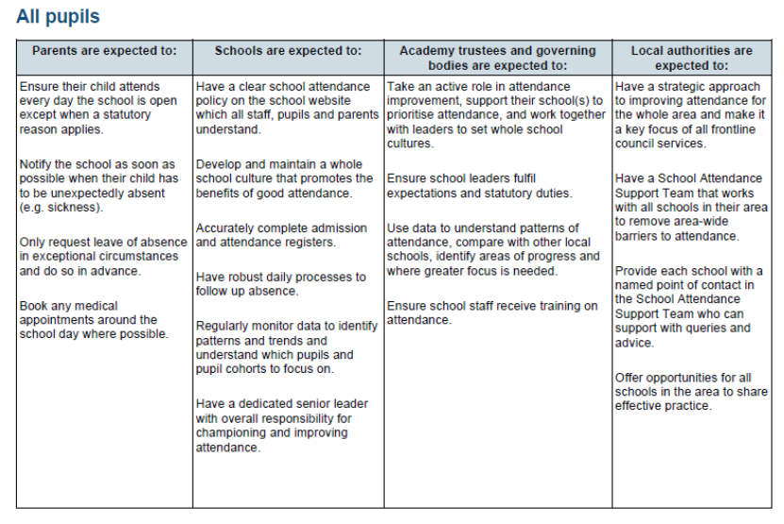

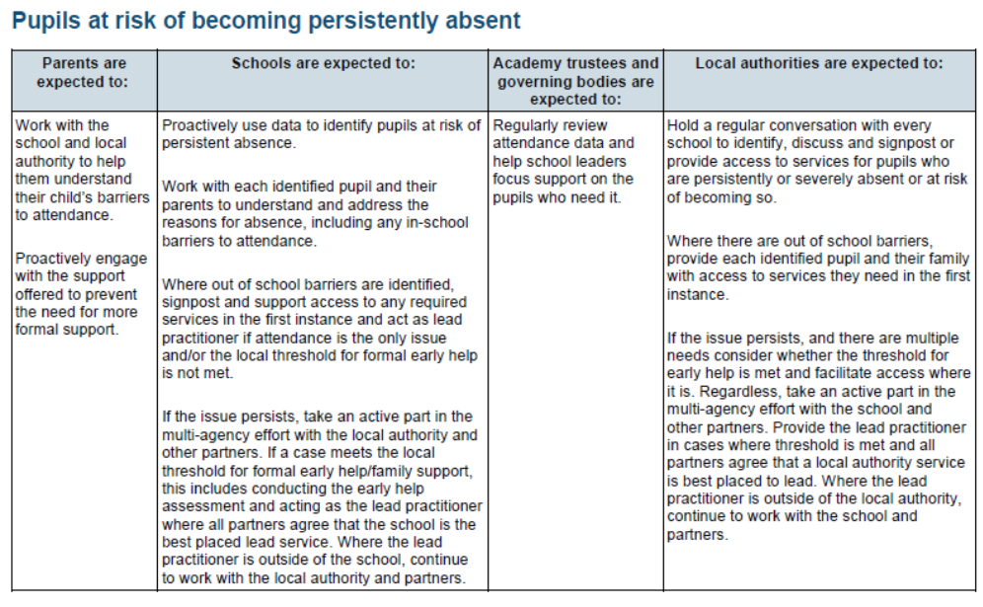
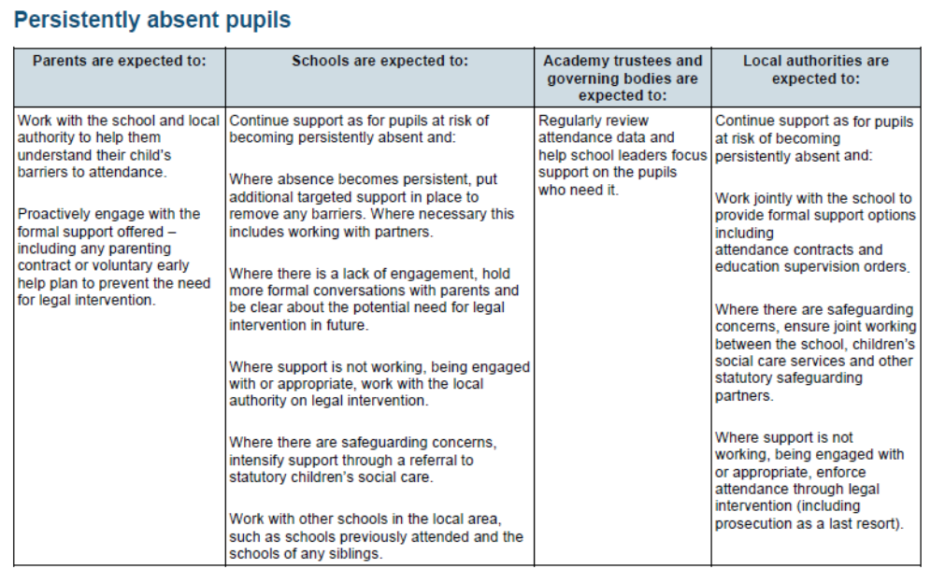

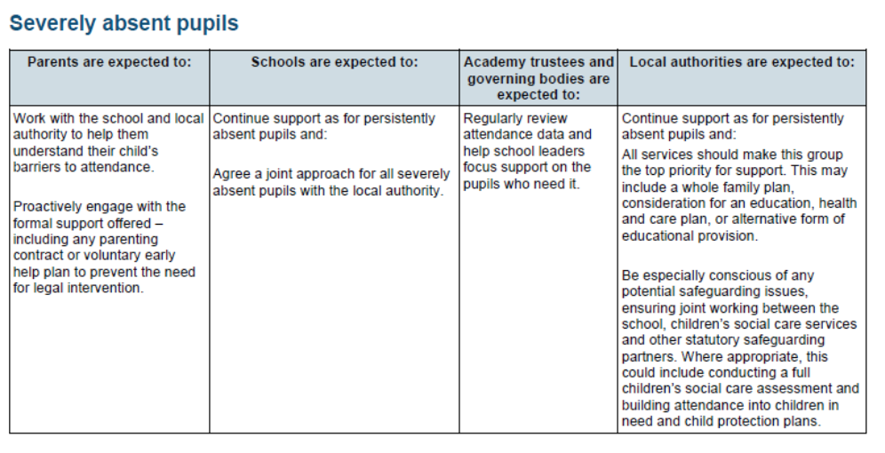

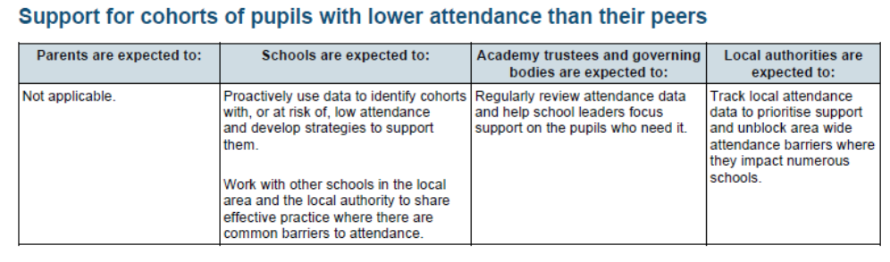
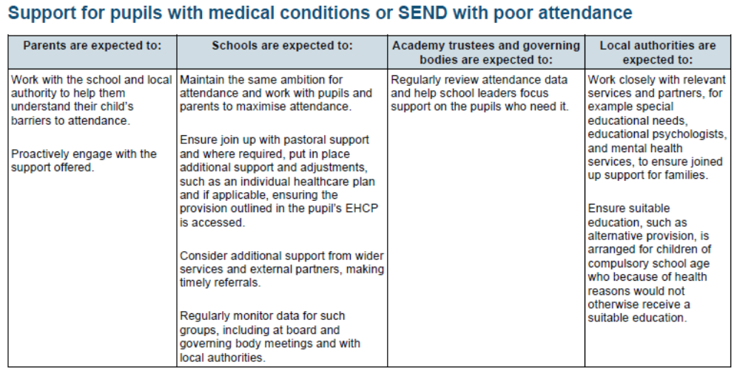
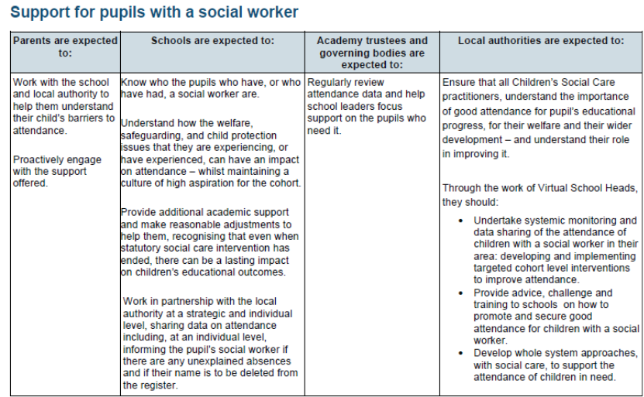

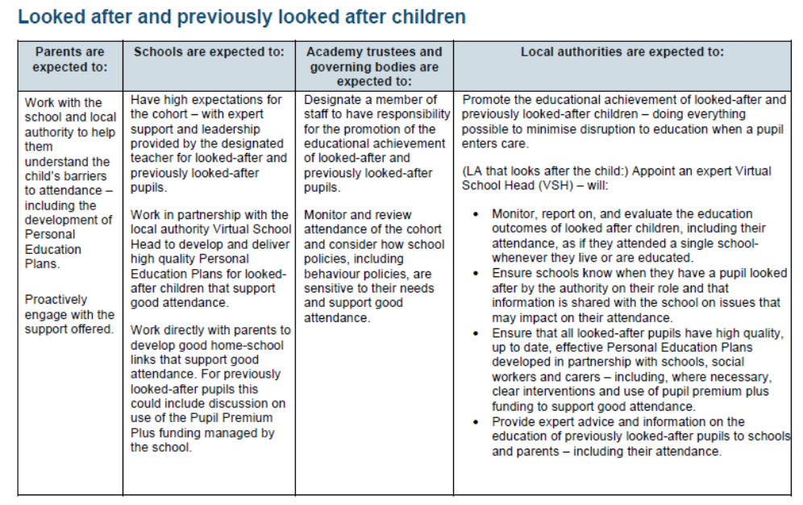

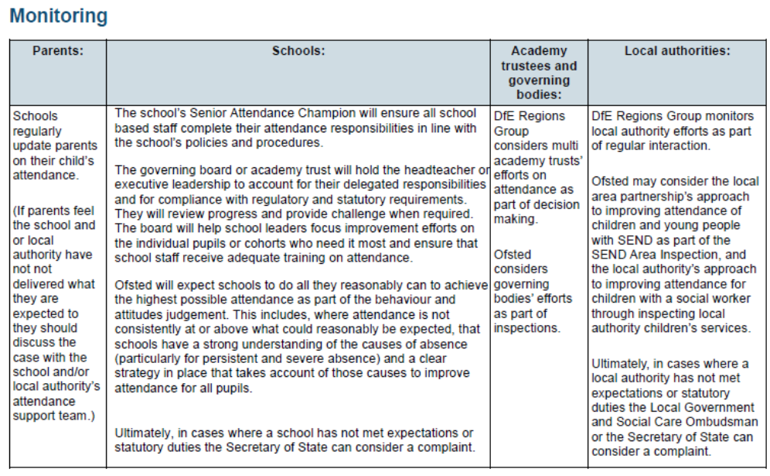

Annex B

ESSEX CODE OF CONDUCT: PENALTY NOTICES FOR PARENTS OF TRUANTS AND PARENTS OF PUPILS EXCLUDED FROM SCHOOL ANTI-SOCIAL BEHAVIOUR ACT 2003 SECTION 23

https://www.essex.gov.uk/schools-and-learning/schools/school-attendance-and-absence/penalty-notices

Annex C

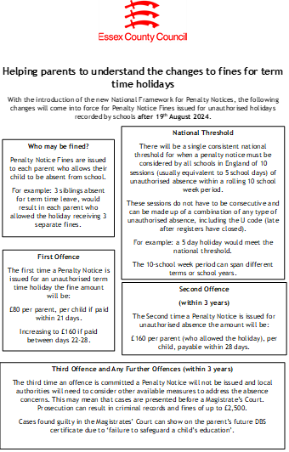

Annex D – Illness Absence Guidance

DfE external document template (childrenscommissioner.gov.uk)

