

Children’s Support Service
Behaviour, Relationships and
Anti-Bullying Policy

The Policy was formally adopted by the Management Committee on: | Date: 25th September 2025  (amended 12/11/25)
Review date: | September 2026

Aims of this policy
To outline how CSS creates an environment, which promotes relationships, engagement, pro social behaviour and also encourages self-regulation and reflection through co-regulation.

Our Vision
“Be the best you can be.”

Our Values

Respect, resilience and aspiration - underpinned by kindness, compassion, connection, hope and belonging.

CSS is a Trauma–Perceptive school:

CSS has embraced the Essex approach to understanding behaviour and supporting emotional wellbeing known as Trauma Perceptive Practice (TPP). This Essex wide approach enables CSS to better understand behaviour and emotional wellbeing and support young people to reach their full potential.

Principles of support:

- A focus on nurture (relationships and trust building)
- A focus on structure (strong routines and boundaries)
- An environment which supports and promotes co-regulation
- An understanding by all of how our brains work and a desire to be curious about behaviour including our own.
- Access to a needs-led provision and targeted support
- Use of educational and protective consequences rather than ‘punishments’
- A strong support network for staff.

Processes, routines, strategies, and interventions used to promote Pro Social behaviour at CSS:

At CSS our culture is to relate, regulate and reason:

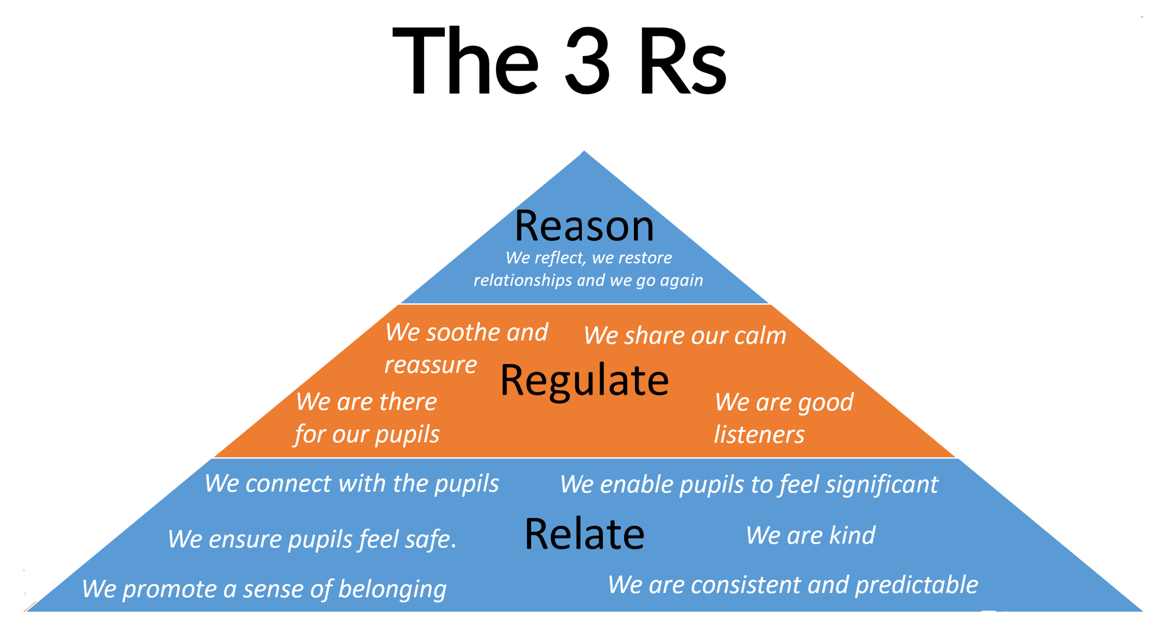

However, it is recognised that due to the different needs of the pupils that attend CSS, a range of strategies may be needed to promote positive behaviour. Strategies used will be personalised to the individual, will be reviewed, and be led by the needs of the pupil.

- Expectations of behaviour are discussed on induction, and the scene is positively set.
- A behaviour assessment is completed as a baseline for behaviour, personal and social skills and used to identify strengths and areas of development.
- All CSS staff are consistent when responding and applying consequences to difficult or unsafe behaviour.
- All staff have access to information about each pupil, both on file and on the Management Information System, and are expected to read and update it.
- All pupils have a personal tutor who has an overview of the pupil’s behaviour and will guide them through their time at CSS.
- Reviews are held regularly for all pupils. Parents and Carers attend alongside any other relevant agencies. Areas in need of attention and support are shared with all relevant staff.
- Pupils have access to ‘social learning’ sessions in the form of breakfast, break, lunch, personal tutor times, and mentoring sessions.
- Engagement mentors support pupils with their behaviour and emotional issues and liaise with outside agencies both inside and outside lessons.
- Individual counselling and/or mentoring is available for all pupils.
- Behaviour Forums are held where pupils causing concern are discussed, and where relevant strategies are identified, reviewed and agreed.
- LABS (learning, attendance, behaviour and safeguarding) meetings are held. Pupils are discussed, and strategies are put in place, recorded and reviewed.
- Any pupil who has an EHC plan is taught according to the plan. Annual reviews are arranged and attended.
- A log is kept by senior leaders of any incidents of bullying and prejudice driven incidents and harmful sexual actions taken and of reviews of the action. These are reported to the Management Committee at each Management Committee meeting.

In addition, all staff at CSS act as positive role models, simply by setting a good example at all times.

Rewards:

CSS believes in promoting within young people internal discipline and an internal motivation to be successful.

However, CSS staff do use rewards when pupils do particularly well in:

- Being positive; trying their best (show a ‘growth’ mind-set)
- Being supportive of others
- Respecting others; respecting their learning environment
- Good or improved attendance

Examples of rewards:

- Positive comments by staff
- Showing good work/sharing compliments of behaviour to senior staff
- Sending home copies of work that has been praised
- Positive contact with home
- Certificates
- Vouchers
- ‘Free choice’ of activity
- Reward breakfast
- Trips
- Addition of enrichment activities to timetable
- Star of the week

“If not you, who? If not now, when?”

It is our collective responsibility to ‘hunt for success.’ Rewards should feature significantly in our culture and ensure our students can “be the best they can be.”

This reinforces our connections and relationships with the students. CSS embraces the the ‘5-1’ rule for every 1 negative we need to balance it out with 5 positives.

Rewards can be issued by any adult in our organisation but especially this must be a part of the work of teachers, TAs, ELT and SLT.

SUCCESS
Level & Points | Rewards – celebrating success
R1 | Demonstrating self-regulation
 | Skills Builder – teamwork
 | Skills Builder – planning
 | Showing consideration for people and property
 | Building positive relationships with adults and peers
R2 | Improved effort today
 | Nominated for student of the week
 | Skills builder - creativity
 | Repeatedly demonstrating positive relationships with adults/peers
 | Sustained effort in class
 | Demonstrating a willingness to "be the best you can be"
 | Showing kindness and compassion
R3 | Going above and beyond our CSS values
 | Skills Builder – adapting (accepting differences and coping with change)
 | Skills Builder – leadership
 | Skills Builder – problem solving
 | Skills Builder – speaking
 | Skills Builder - listening
 | Participation in enrichment activity
 | Student of the week
 | Demonstrating resilience
 | Positive support of a peer/adult
 | Sustained effort in this subject over at least 5 lessons
 | Consistently achieving reintegration targets
 | Aspiring to achieve more
 | Positive community contribution
 | Engaging positively with a visitor
R4 | Representing CSS in an event
 | Over 85% attendance to class/a subject this half term
R5 | Achievement of subject accreditation e.g. functional skills, AQA award, swimming badge
 | SLT Over 85% attendance to school this half term
 | Jack Petchey Nomination
 | ELT/SLT Exceptional contribution to school life

Challenging Behaviour:

At times, it is acknowledged that some pupils may display difficult or unsafe behaviours. In such circumstances, approaches will be in proportionate to the harm that could be caused and to the needs of the young person. It is important to acknowledge that it is the behaviour, not the pupil, which is being challenged.

All staff at CSS challenge low level poor behaviour by describing the behaviour they expect to see:

Examples:

“David, we use polite language, thanks”
“David, we walk in the corridors, thank you”

- We use the pupils name to add a sense of significance and responsibility.
- We use the term “we” to add a sense of belonging.
- We describe the desired behaviour to ensure the pupil is clear on our expectations and on what we expect them to do.
- We end in “thanks” or “thank you” as CSS staff always treat pupils with respect.

The ‘Stepped Approach’ below illustrates the expected staff actions in response to difficult or unsafe behaviour. The process can start at any step. For example, if a pupil swears, the member of staff would start at step 4. For a serious incident, a member of staff may start at step 5.

Step 1

Positive Praise, Positive attention, Relationship Building

Step 2
Low intrusive staff action: such as
Tactically ignoring, or a Silent Signal or by Praising other pupil’s behaviour

Step 3

Step 4
Medium intrusive staff action: such as
Describing the behaviour you expect from the pupil – our Expectation

Use the language of Choice stating a consequence: such as
“John, if you choose to shout out again I will ask you to move seats”

Step 5

Issue the consequence: “John, you chose to shout out again therefore move seats, thank you”

Step 6
If the pupil refuses to carry out the consequence issue a higher level consequence: such as
“John, if you choose not to move seats I will speak to you at the end of the lesson”

If a pupil is dysregulated, rather than discussing consequences or using the language of choice we co-regulate. We soothe and reassure.

At CSS we share our calm

Only when a pupil is regulated do we discuss consequences or the use the language of choice. By co-regulating we teach how to self-regulate.
The CSS co-regulation script:

- Pupil’s name
- “I can see something has happened”
- “I will do my best to help”
- “Talk and I will listen”

- “Let us ………….. or ……………. ”

In addition, the following strategies are also used in response to poor behaviour:

- A quiet verbal warning and reminder of the expectation.
- Gentle reminders of expectations
- Distraction task – a change of task can diffuse a situation
- Differentiated work/personalised learning task
- Take up time – give the pupil time to change their behaviour/make a different choice
- Positive comments – reminders of previous successes/gentle praise/words of encouragement
- Change of environment – if appropriate, a change of location can help
- Reminders of personal goals – they may be close to achieving a certain number of merits

Consequences:

Types of consequence used at CSS:

Proactive (to protect the rights of others)

- Increased staff ratio
- Change of Timetable
- Limited access to outside space
- Escorted in social situations
- No availability of minibus/car
- Differentiated teaching space
- Suspension

Educational Consequence (to motivate and support the pupil to behave differently next time)

- Completing tasks
- Rehearsing
- Assisting with repairs
- Educational opportunities
- Putting things right
- Research
- Restorative meetings
- CHOICES

Level & Points | Choices
C1 – all teachers & TAs | Late for lesson/school
 | Incorrect use of equipment
 | Incorrect uniform
 | Inappropriate language or terms
 | Not following basic instructions e.g. continuing to talk, not sitting down
 | Not giving best effort in class
 | New - Leaving timetabled lesson without permission
C2 – all teachers & TAs | Low level defiance
 | Entering a classroom not on your timetable
 | Accessing a space without permission
 | Allowing another student to enter a room not on their timetable
 | Using derogatory terms that cause hurt or upset to others
 | Verbally abusing an adult or child
 | Medical/Remote – Not visibly engaging in learning
C3 -all teachers & TAs | Verbally threatening an adult or child
 | Throwing objects
 | Persistently choosing non-compliance
 | Leaving the site (less than 10 mins)
 | Dangerous behaviour
 | Graffiti
 | Deliberately damaging equipment or property
 | Persistently disrupting learning
 | Not attending lesson when on site
 | Mobile phone use
C3 ELT/SLT only | ELT/SLT Choices which do not align with CSS values (repeated C1,C2 C3 incidents)
C4 SLT only | SLT Theft
 | SLT Substance abuse - drugs
 | SLT Substance abuse - alcohol
 | SLT Discriminatory behaviour towards protected characteristics
 | SLT Drug related
 | SLT Leaving site for 10 minutes or more
 | SLT Physical altercations
 | SLT Bullying/on-line bullying
 | SLT Assault of an adult or child
 | SLT Extreme dangerous behaviour (setting off fire alarm/extinguisher included)
 | SLT Smoking/vaping
 | SLT Choices which do not align with CSS values

At CSS we teach all pupils about how their brains work and the impact of stress on their ability to make good decisions. We use the Upstairs & Downstairs model of the brain to explain this.

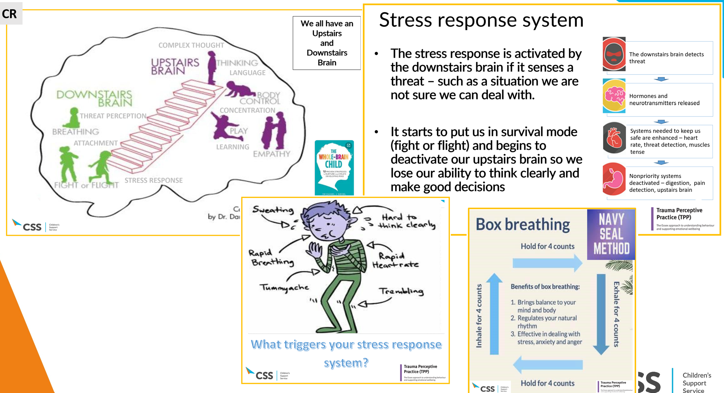

Fixed Term Exclusions:

Fixed term exclusions are issued by the Head of Service as recommended by the Head of Centre. They are only used when allowing a pupil to remain on site would seriously harm the education or welfare of the pupils or others in the Centre. The decision will be based on the circumstances and individual needs of the pupil.

Examples of behaviour might include:

C5 | (VP) Verbal abuse / threatening behaviour against a pupil
 | (VA) Verbal abuse / threatening behaviour against an adult
 | (TH) Theft

(SM) Sexual misconduct
(RA) Racist abuse
(PP) Physical assault against a pupil
(PH) Wilful and repeated transgression of protective measures in place to protect public health
(PA) Physical assault against an adult
(OW) Use or threat of use of an offensive weapon or prohibited item
(MT) Inappropriate use of social media or online technology
(LG) Abuse against sexual orientation and gender identity
(DS) Abuse relating to disability
(DM) Damage to property
(DB) Persistent or general disruptive behaviour
(DA) Drug and alcohol related
(BU) Bullying

Restrictive physical interventions and the use of force:

At CSS “physical force” will never be used to force compliance and will only be used as a last resort and when all other strategies have been tried or considered.

There are occasions when CSS staff will have cause to make physical contact with pupils for a variety of reasons, for example:

- to comfort a pupil in distress (so long as this is appropriate to their age);
- to praise a pupil
- to gently direct a pupil
- for curricular reasons (for example in PE, Drama etc.)
- in an emergency to avert danger to the pupil/pupils or staff
- in rare circumstances, when Restrictive Physical Intervention is warranted.

“Restrictive Physical Intervention” is the term used to describe interventions requiring the use of “reasonable physical force” to control or manage a child’s behaviour.

All staff at CSS receive training every year on using Restrictive Physical Interventions by trained PRICE staff. Refresher training is delivered termly to each Centre and Medical Reintegration Team. In addition, trained PRICE staff are available to give advice and guidance when required.

CSS considers that:

- The use of force can only be regarded as reasonable if the circumstances of an incident warrant it; i.e. it is absolutely necessary.
- The degree of force must be in proportion to the circumstances of the incident, age and understanding of the child and the seriousness of the consequences or harm it is intended to prevent.

Situations that may require a Restrictive Physical Intervention:

- To prevent a child from injuring themselves or others
- To prevent a child from committing a criminal offence
- To prevent or stop a child from causing serious damage to property (including the child’s own property)

At CSS, Restrictive Physical Interventions are only used as an act of care and control, not to force compliance. All staff are responsible for the safeguarding of our children and therefore all staff are authorised by the head teacher to use physical force (which is deemed reasonable, proportional and necessary) to keep our pupils safe
We also take the view that staff should not be expected to put themselves in danger and that removing other children and themselves from risky situations may be the right thing to do.

All staff have Continual Professional Development in co-regulation and managing challenging situations, and the use of force.

All Restrictive Physical Interventions that take place at CSS are recorded.

All complaints or disputes which arise about the use of force by a member of staff will be dealt with according to our Child Protection and Safeguarding policy.

Screening and searching children and young people

At CSS we are all aware that there are legal provisions which enable our staff to confiscate items from children and young people:

DfE Advice for Schools July 2022 - Searching, Screening and Confiscation (publishing.service.gov.uk)

From this guidance our staff understand that they may, with the Head of Centres’ permission (or appropriate senior leader) confiscate items that are of high value, deemed inappropriate and are against the school policies or are causing concern. Where a specific policy about the item does not exist, the member of staff should use their discretion about whether the item is returned to the child/young person or to their parent/guardian. Items returned to them should usually be returned no later than the end of that school day. If the item needs collecting by a parent/guardian, the teacher should ensure that the parent/guardian is made aware that an item has been confiscated – either through the child/young person or via text/phone call. Where the item is of high value or deemed inappropriate, contact should be made directly with the parent/guardian.

- knives and weapons
- alcohol
- illegal drugs
- stolen items
- tobacco and cigarette papers
- fireworks
- pornographic images
- any article that has been or is likely to be used to commit an offence, cause personal injury or damage to property; and any item banned by the school rules which has been identified in the rules as an item which may be searched for.

Bullying:

Bullying is not tolerated at CSS.

Bullying is anti-social and will not be tolerated from any member of our community. It is vital that we encourage respect for others and work to prevent all forms of bullying.

Students should be alert to signs of bullying and act promptly and firmly, demonstrating to others that this issue is taken seriously and that the situation will not be allowed to continue.
Bullying encompasses a wide range of behaviours.

Bullying is defined as deliberately hurtful behaviour, repeated over a period of time, where it is difficult for those being bullied to defend themselves. Bullying can be:

- Emotional: being unfriendly, excluding, tormenting (e.g., hiding books, threatening gestures).
- Physical: pushing, kicking, hitting, punching or any use of violence.
- Racist: racial taunts, graffiti, gestures.
- Sexual: unwanted physical contact or sexually abusive comments.
- Homophobic: because of or focussing on sexuality.
- Transphobic: because of or focussing on transgender.
- Verbal: name-calling, sarcasm, spreading rumours, teasing.
- Cyber: all areas of internet, such as email and internet chat room misuse, mobile threats by text messaging and calls, misuse of associated technology, i.e., camera &video facilities.
- Intellectual/Neurodiversity (SEND): Being unfriendly, excluding, and abusive to another because of one’s educational needs

To be defined as bullying, the offending behaviour is repetitive (has this happened before?), deliberate/ intentional (Has the alleged perpetrator purposely gone to cause harm or distress?) and there is an imbalance of power (Does the alleged perpetrator hold the power within the incident?) Power is influenced by a range of factors including but not limited to; gender, intelligence, size, age, experience, qualifications, and knowledge.

In all cases of bullying, the victim is unable to defend themself, resulting in persistent distress. It is important to remember that it is often difficult to tell the extent of the hurt or upset caused to individuals who are bullied.

Bringing this issue out into the open amongst students will lead to greater understanding of the nature of the problem and will encourage more people to confront and tackle bullying. Clearly understood systems, in place across the Service will ensure that every opportunity is given to empower the victims of bullying and re-educate the perpetrators

Any reports of bullying are taken seriously and all incidents are recorded on MyConcern. Incidents are investigated with the aim that matters should be resolved as quickly as possible.

CSS follows all guidance within the Equality Act 2010: guidance - GOV.UK (www.gov.uk)

Prevention of bullying

We encourage a positive approach to the prevention of bullying through cross-curricular activities, particularly in Personal, Social, and Health Education.

We provide opportunities to:

- Encourage children to talk about their feelings:
- Promote understanding of friendship through co-operative work/play situations in and out of the classroom and by the understanding of friendship taught through the PSHE curriculum.
- Maintain a consistent approach to unacceptable behaviour by all members of staff.
- Treat all children fairly and equally (which sometimes means treating them differently)
- Praise positive behaviour through the school's reward system.
- Teach children to know what acceptable/unacceptable behaviour is and why.

Incidents of bullying may be reported by:

- A parent/guardian of a child who is being bullied.
- A child who is being bullied.
- Other children not directly involved in the bullying.
- A member of staff.

Procedures to follow if an incident of suspected bullying is reported:

All claims of bullying will be taken seriously and investigated promptly.
If a suspected incident of bullying is reported to a member of staff, they will ensure that other key staff are informed.

The member of staff should speak to the child/children involved. This may be on an individual or group basis depending on the teacher's/member of staff's interpretation of the incident. The member of staff involved should try to ascertain accurate details by:

- Taking the incident seriously.
- Ensuring the situation is dealt with swiftly and sensitively.
- Listening to both/all sides of the reported incident.
- Reassuring the victim
- Making sure that all parties involved understand what behaviour/action is being disapproved of and why.
- Being seen to treat all parties fairly and with a consistent approach.
- Trying to decide on a positive course of action for all parties and for all parties to agree/understand the reasons behind the agreed action to prevent recurrence of unwanted incidents through the implementation of the “No-Blame” approach
- Informing the parents/carers
- Recording the details of the incident and actions
- Reporting data of incidents to the Management Committee

Engagement Mentors may be used to work with the children involved and use
restorative approaches to resolve the conflict.

All suspected incidents of bullying are reported to the DSL for the area of the Service who is also a member of SLT.

If the reported incident is judged to be bullying, then a copy of key details relating to the target(s) and perpetrator are held on MyConcern. This report should include:

- who was involved (or alleged to be)
- where and when the event(s) happened
- what happened
- what action was taken
- how action was followed up

It must be remembered that both the perpetrator and the target(s) may need help to prevent the actions reoccurring.

The role of the Management Committee:

The Management Committee supports the Head teacher in all attempts to eliminate bullying. The members require the Head teacher to keep accurate records of all incidents of bullying, and to report to the governors on request.

A parent/family who is dissatisfied with the way the school has dealt with a bullying incident can ask the chair of the Management Committee to look into the matter.

The governing body responds within ten days to any request from a parent to investigate incidents of bullying. In all cases the governing body notifies the Headteacher, and asks him/her to conduct an investigation into the case, and to report back to a representative of the governing body. Incidents of bullying are reported at each CSS Management Committee meeting.

The role of parents/families

Parents have a responsibility to support the school’s anti-bullying policy, actively encouraging their children to be a positive member of the school/community.

Any parents who suspect that their child may be the target of bullying or who believe that their child may be the perpetrator of bullying, should contact their child’s class teacher immediately. All cases of suspected bullying will be thoroughly investigated.

If parents are not satisfied with the response from staff, they should contact the appropriate senior manager who will then carry out a further investigation into the incident.

The role of pupils:

Pupils are encouraged to tell anybody they trust if they are being bullied, and if the bullying continues, they must keep on letting people know.

Pupils are invited to tell us their views about a range of school issues, including bullying, through pupil perceptions and pupil questionnaires.

Pupils are also encouraged to be positive role models for others within the school community.

Monitoring and review:

This policy is monitored, and data is reported to members of the Management Committee.
Further Guidance

- Keeping children safe in education - GOV.UK (www.gov.uk)

- Behaviour in schools guidance Sept 2022

- Reducing the Need for Restraint and Restrictive Intervention June 2019

- Suspension and Permanent Exclusion Sept 2022

- Searching, Screening and Confiscation July 2022

- Positive environments where children can flourish (2021)

- Creating a Culture: how school leaders can optimise behaviour (DfE, 2017)

